MGT 40750 – Quantitative Decision Modeling Fall 2017

**Assignment 2: Linear Programming**

***Due Date: 09/13/2017 (Wednesday)***

**Name(s): ______________________________________________________**

*Make sure all your group members (no more than 3) sign here.*

There are four questions (15 total points) in this assignment. All relevant Excel files can be found on Sakai. Solve these questions in Excel and fill in the solution template provided below.

**Question 1: Problem 50 on page 200 in the PMS 5th Ed textbook (just part a).**

Sunblessed Juice Company sells bags of oranges and cartons of orange juice. Sunblessed grades oranges on a scale of 1 (poor) to 10 (excellent). At present, Sunblessed has 100,000 pounds of grade 9 oranges and 120,000 pounds of grade 6 oranges on hand. The average quality of oranges sold in bags must be at least 7, and the average quality of the oranges used to produce orange juice must be at least 8. Each pound of oranges that is used for juice yields a revenue of $1.50 and incurs a variable cost (consisting of labor costs, variable overhead costs, inventory costs, and so on) of $1.05. Each pound of oranges sold in bags yields a revenue of $1.50 and incurs a variable cost of $0.70. Determine how Sunblessed can maximize its profit.

Step 1: Specify the Excel file Question1.xlsx. Make sure to record *all the necessary formulas*.

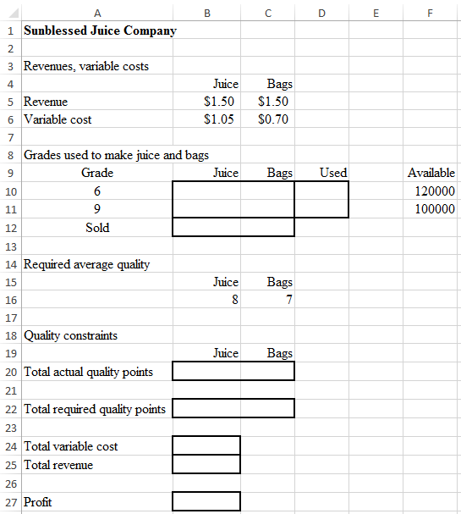

Step 2: Specify Solver

Set Objective: _________

To: ○ Max ○ Min ○ Value of: _________

By Changing Variable Cells: ______________________________________________________

Subject to the Constraints:

|  |
| --- |
|  |

□ Make Unconstrained Variables Non-Negative

Select a Solving Method: Simplex LP

Step 3: Report your results below.

|  |  |  |
| --- | --- | --- |
| Grades used to make juice and bags | | |
| Grade | Juice | Bags |
| 6 |  |  |
| 9 |  |  |

The optimal profit is ____________.

Step 4: Sunblessed Juice Company is considering purchasing more grade 9 oranges. How much would Sunblessed Juice Company be willing to pay for additional 1,000 pounds of grade 9 oranges?

____________

Explain your answer.

______________________________________________________________________________________________________________________________________________________________________________________________________________________________________________________________________________________________________________________________________________________________________________________________________

**Question 2: Problem 51 on page 200 in the PMS 5th Ed textbook.**

A bank is attempting to determine where its assets should be invested during the current year. At present, $500,000 is available for investment in bonds, home loans, auto loans, and personal loans. The annual rates of return on each type of investment are known to be the following: bonds, 10%; home loans, 16%; auto loans, 13%; and personal loans, 20%. To ensure that the bank’s portfolio is not too risky, the bank’s investment manager has placed the following three restrictions on the bank’s portfolio:

* The amount invested in personal loans cannot exceed the amount invested in bonds.
* The amount invested in home loans cannot exceed the amount invested in auto loans.
* No more than 25% of the total amount invested can be in personal loans.

Help the bank maximize the annual return on its investment portfolio.

Step 1: Specify the Excel file Question2.xlsx. Make sure to record *all the necessary formulas*.

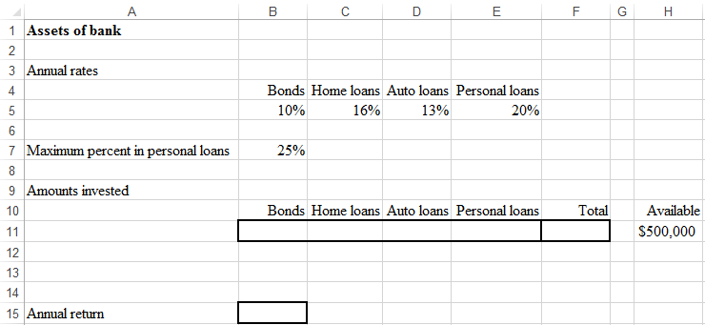

Step 2: Specify Solver

Set Objective: _________

To: ○ Max ○ Min ○ Value of: _________

By Changing Variable Cells: ______________________________________________________

Subject to the Constraints:

|  |
| --- |
|  |

□ Make Unconstrained Variables Non-Negative

Select a Solving Method: Simplex LP

Step 3: Report your results below.

|  |  |  |  |
| --- | --- | --- | --- |
| Amounts invested | | | |
| Bonds | Home loans | Auto loans | Personal loans |
|  |  |  |  |

The optimal annual return is ____________.

**Question 3: Problem 60 on page 202 in the PMS 5th Ed textbook.**

Abotte Products produces three products, A, B, and C. The company can sell up to 300 pounds of each product at the following prices (per pound): product A, $10; product B, $12; and product C, $20. Abotte purchases raw material at $5 per pound. Each pound of raw material can be used to produce either one pound of A or one pound of B. For a cost of $3 per pound processed, product A can be converted to 0.6 pounds of product B and 0.4 pounds of product C. For a cost of $2 per pound processed, product B can be converted to 0.8 pounds of product C. Determine how Abotte can maximize its profit.

*Step 1: Specify the Excel file Question3.xlsx. Make sure to record all the necessary formulas.*

*Hint: Use B18:C18,B20:C20 as the decision variables.*

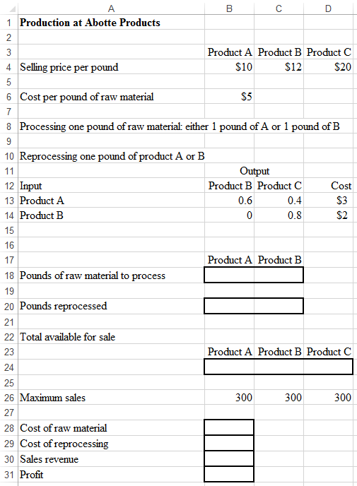

*Step 2: Specify Solver*

Set Objective: _________

To: ○ Max ○ Min ○ Value of: _________

By Changing Variable Cells: ______________________________________________________

Subject to the Constraints:

|  |
| --- |
|  |

□ Make Unconstrained Variables Non-Negative

Select a Solving Method: Simplex LP

*Step 3: Report your results below.*

|  |  |  |
| --- | --- | --- |
|  | Product A | Product B |
| Pounds of raw material to process |  |  |
| Pounds reprocessed |  |  |

The optimal profit is ____________.

**Question 4: Problem 95 on page 207 in the PMS 5th Ed textbook (just do part a).**

Mondo Motorcycles is determining its production schedule for the next four quarters. Demands for motorcycles are forecasted to be 400 in quarter 1; 700 in quarter 2; 500 in quarter 3; and 200 in quarter 4. Mondo incurs four types of costs, as described here:

* It costs Mondo $800 to manufacture each motorcycle.
* At the end of each quarter, a holding cost of $100 per motorcycle left in inventory is incurred.
* When production is increased from one quarter to the next, a cost is incurred primarily for training employees. If the increase in production is *x* motorcycles, the cost is $700*x*.
* When the production is decreased from one quarter to the next, a cost is incurred, primarily for severance pay and decreased morale. If the decrease in production is *x* motorcycles, the cost is $600*x*.

All demands must be met on time, and a quarter’s production can be used to meet demand for the current quarter (as well as future quarters). During the quarter immediately preceding quarter 1, 500 Mondos were produced. Assume that at the beginning of quarter 1, no Mondos are in inventory.

Determine how to minimize Mondo’s total cost during the next four quarters.

Step 1: Specify the Excel file Question4.xlsx. Make sure to record *all the necessary formulas*.

*Hint: Use B14:E15 as the decision variables.*

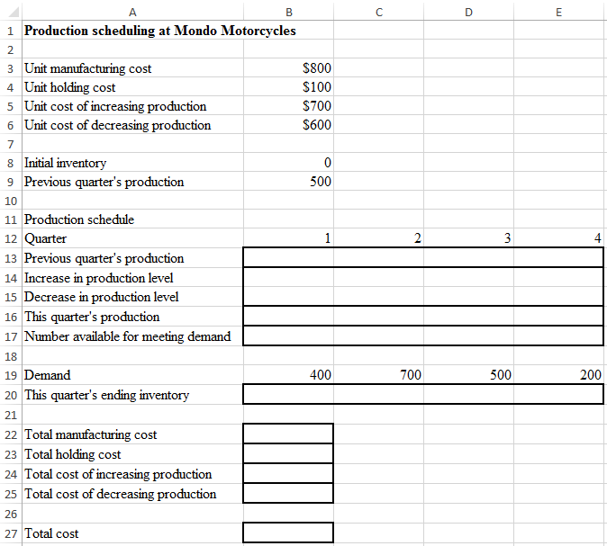

Step 2: Specify Solver

Set Objective: _________

To: ○ Max ○ Min ○ Value of: _________

By Changing Variable Cells: ______________________________________________________

Subject to the Constraints:

|  |
| --- |
|  |

□ Make Unconstrained Variables Non-Negative

Select a Solving Method: Simplex LP

Step 3: Report your results below.

|  |  |  |  |  |
| --- | --- | --- | --- | --- |
| Quarter | 1 | 2 | 3 | 4 |
| Increase in production level |  |  |  |  |
| Decrease in production level |  |  |  |  |

The optimal total cost is ____________.